# MCj04124640000[1]Small Reporter

## September/October 2015

#### **School News**

Traditionally, in September 2015, we had **“ A Week of Upbringing”** in our school. Each year we point out how important is to be a good person, to be tolerant and to respect others.

upbringing – wychowanie point out – wskazywać respect others – szanować innych

**Remember!**

***30th September***

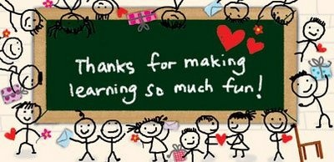

***14th October***

***The Day of Education***



***16th October John Paul’s Day***

***Pope John Paul II will be declared saint on 27th April 2014.***

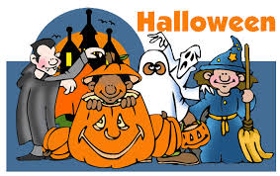***31st October***

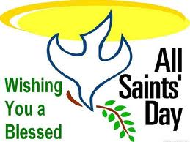

***1st November***

**Easy English**

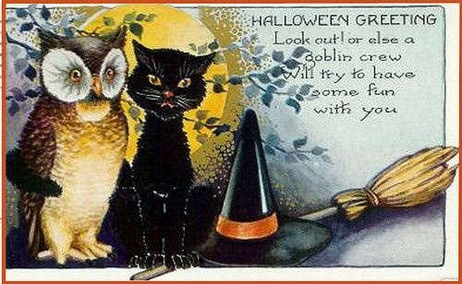

**Halloween card**

**with greetings**

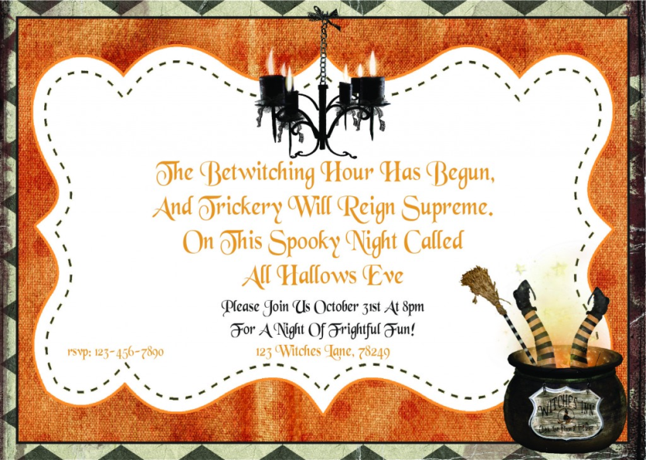

**Halloween party**

**invitation**

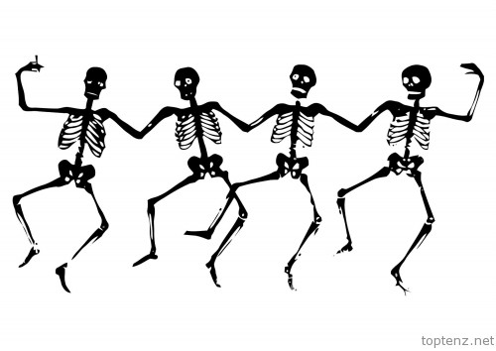**Culture zone**

**Halloween, one of the world's oldest holidays, is celebrated around the world with a variety of spooky and fun traditions.**

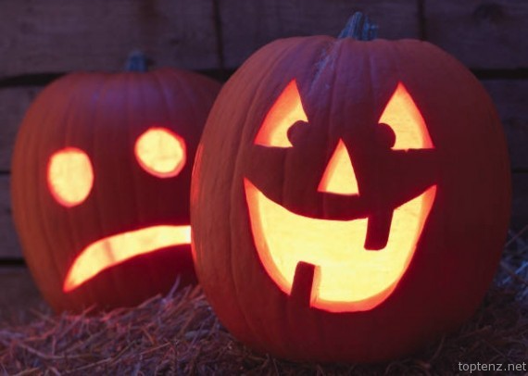

**Jack-o'-lanterns have been a part of Halloween celebrations for centuries.**

**Did You Know?**

**One quarter of all the candy sold annually in the U.S. is purchased for Halloween.**

**1. Witches 2. Jack O’Lanterns 3. Masks and Costumes**

**4. Ghosts 5. Skeletons 6. Black Cats 7. Bats 8. Spiders**

**9. The Colours Orange and Black 10. Corn Husks and Stalks of Wheat**

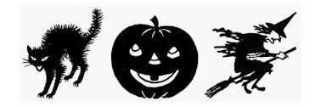

**Teenagers’ corner**

**We have a right:**

1. **to be different from others**
2. MCj04295750000[1]**to have our own ideas and secrets**
3. **to choose friends**
4. **to be respected by others**
5. **to be protected by the law**
6. **to play not work**
7. **to free education**
8. **to free healthcare**
9. **to live in a loving family**
10. **to have rights**

**different** – inny, różny **right** – prawo **others** – inni (ludzie) **idea** – pomysł

**secret** – tajemnica **choose** – wybierać **respect** – szanować **protect** – chronić

**the law** – prawo **free** - bezpłatny **healthcare** – opieka zdrowotna

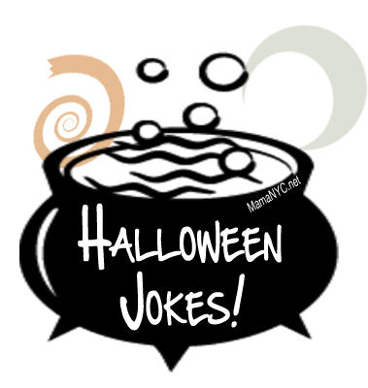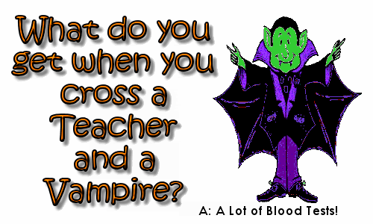**Jokes**

|  |  |
| --- | --- |
| **Time for a quiz**    Name………………………………  Surname……………………………  Class………………………………. | ***Have a lot of fun!***    **Opiekun redakcji gazetki: Katarzyna Skit** |

The next issue in November!