# Small Reporter

## February/March 2017

#### Znalezione obrazy dla zapytania karnawa&lstrok;**School News**

MC900412540[1]*On 28th January we had a carnival party in our school. Students from classes 1-3 were dressed up as princesses, witches, animals and other creatures.*

**Remember!**

**8th March – Women’s Day**

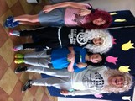

**21st March – the first day of… *SPRING*** - one of the four seasons of the year. In spring the whole world comes back to live.

*come back to life – powracać do życia*

*On this day you can tell as many lies as you wish. You can also play funny tricks on people and you won’t be punished because of that.*

tell lies – kłamać play tricks on people – robić komuś psikusy be punished – być ukaranym

**Culture zone**

MC900343443[1]**Women’s day – 8th March was celebrated for the first time in 1911 to commemorate women’s rights to vote and to have better working conditions. On this day, a group of working women went on strike. The owner of the factory locked the women trying to hide the strike. Unfortunately, the factory burst into flames and 129 women died.**

celebrate – obchodzić, świętować commemorate – upamiętniać vote – głosować working conditions – warunki pracy owner – właściciel factory – fabryka lock – zamknąć na klucz hide – ukryć unfortunately – niestety burst into flames – stanąc w płomieniach

**Easy English**

Czasownik "mieć" w angielskim można wyrazić na parę różnych sposobów.

* I have an English book.
* I've got an English book.
* I have got an English book.
* I got an English book.

Wszystkie te zdania oznaczają "mam angielską książkę".

**Angielski czasownik leksykalny HAVE służy do budowy pytań,** w których jest on głównym czasownikiem zdania np.:

* **Have** you got [a](http://www.tlumaczenia-angielski.info/angielski/articles.htm) house? (Czy masz dom?)
* **Have** you any coffee? (Czy masz kawę?)

**Czasownik Have można również zaprzeczyć** w taki sam sposób jak "to be", tzn poprzez dodanie NOT po czasowniku np.:

* I **have not** got coffee. (Nie mam kawy).
* She **has not** got a house. (Ona nie ma domu).

"Have not" i "has not" można skrócić do formy "haven't" i "hasn't".

|  |  |
| --- | --- |
| **ODMIANA CZASOWNIKA HAVE GOT** | |
| **LICZBA POJEDYnCZA** | |
| I've got | I haven't got |
| you've got | you haven't got |
| he**'s got** | she **hasn't got** |
| she**'s got** | he **hasn't got** |
| it**'s got** | it **hasn't got** |
| **LICZBA MNOGA** | |
| we've got | we haven't got |
| you've got | you haven't got |
| they've got | they haven't got |

MC900198594[1]

***A history joke***

***Teacher: What was Camelot?  
Pupil: A place where people parked***

***their camels!***

***An ideal homework excuse***

***Teacher: Where is your homework?  
Pupil: I lost it fighting this kid who said***

***you weren't the best teacher in the school.***

***Teacher: Name two days of the week that start with "t".  
Pupil: Today and Tomorrow.***

***Son: Today my teacher yelled at me for something I didn’t do.  
Father: What was that?  
Son: My homework!***

park – parkować camel – wielbląd excuse - wymówka lose (lost) – zgubić fight – walczyć yell – krzyczeć, wrzeszczeć

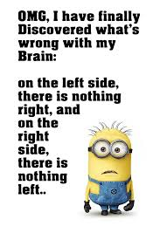

**Time for a quiz – Solve the puzzle**

|  |  |  |  |  |  |  |  |  |  |  |  |  |  |  |  |  |  |  |
| --- | --- | --- | --- | --- | --- | --- | --- | --- | --- | --- | --- | --- | --- | --- | --- | --- | --- | --- |
|  |  |  |  |  |  | 1. |  |  |  |  |  |  |  |  |  |  |  |  |
|  |  |  |  |  |  | 2. |  |  |  |  |  |  |  |  |  |  |  |  |
|  |  |  | 3. |  |  |  |  |  |  |  |  |  |  |  |  |  |  |  |
|  |  | 4. |  |  |  |  |  |  |  |  |  |  |  |  |  |  |  |  |
|  |  |  |  | 5. |  |  |  |  |  |  |  |  |  |  |  |  |  |  |
|  |  |  |  |  | | 6. |  |  |  |  |  |  | | |  |  | | |

1. 2. 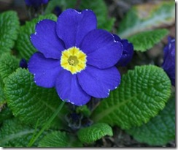 3. 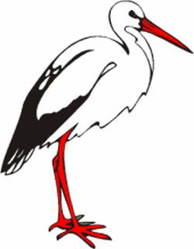

4.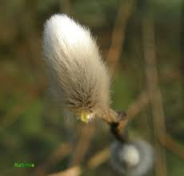 5.  6. 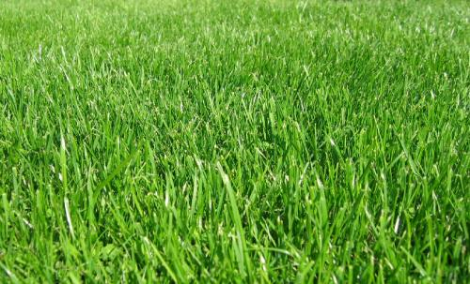

|  |  |
| --- | --- |
| Name………………………………  Surname……………………………  Class………………………………. | **Opiekun redakcji gazetki:**  **Katarzyna Skit** |