# Small Reporter

## March 2014

#### Znalezione obrazy dla zapytania serduszko**School News**

***14th February was an unusual day in our school. Surrounded by red hearts symbolizing LOVE we celebrated this incredible day. We sent lost of Valentine’s Cards to our friends. ☺ It’s a nice feeling to get a card. ☺***

MCj03986050000[1]unusual – niezwykły surrounded – otoczony symbolizing – symbolizujący incredible – niesamowity feeling - uczucie

**8th March – Women’s Day**

**Best wishes from all boys!**

**Remember!**



***1st April – April Fool’s Day*** On this day we play tricks on other people. April Fool jokes are in good fun and not meant to harm anyone. The most clever April Fool joke is the one where everyone laughs, especially the person upon whom the joke is played. laugh – śmiać się good fun – dobra zabawa play tricks on sb– żartować z kogoś harm – skrzywdzić clever – inteligentny, sprytny

**20th March – the first day of *SPRING***

MCj01940520000[1]**Culture zone**

***Easter is coming…***

***Easter calendar:***

*13th April –* ***Palm Sunday*** *– get palms to church!*

*18th April –* ***Good Friday*** *– the day of the crucifixion of Jesus.*

*19th April – get Easter baskets to church!*

*20th April –* ***Easter Day*** *– the day of the resurrection of Jesus.*

*21st April –* ***Easter Monday*** *– prepare to be wet!*

***What can you find in the Easter basket?***

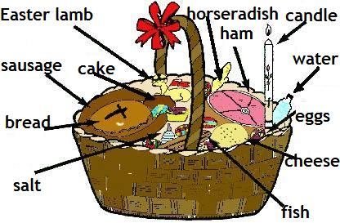

MCj02873840000[1]**The Easter Bunny’s feet**

**Go hop, hop, hop**

**His big, pink ears**

**Go flop, flop, flop…**

**He hops a long way**

**With eggs for Easter Day**

**Hop, flop, hop, flop, hop…**

**Easy English: Signs of the Zodiac**

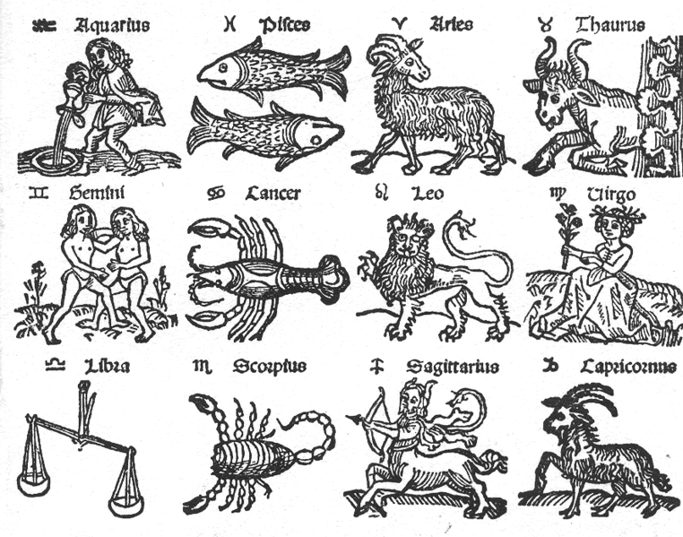

|  |
| --- |
|  |

MCj04283950000[1]http://www.crewsnest.vispa.com/easterjokesline.jpg **Jokes**  
  
  
 - What do you get when you pour hot water down a rabbit hole?  
 - A Hot Cross bunny.

|  |  |  |
| --- | --- | --- |
| **Time for a quiz** | |  | | --- | | Name………………………………  Surname……………………………  Class………………………………. |   MCj04130180000[1]  Opiekun redakcji gazetki:  **Katarzyna Skit** |

* How do you post a bunny? - Hare mail.
* How do bunnies stay healthy? - Eggercise

easterjokesline  
- Do you know how bunnies stay in shape?  
- Hareobics.