Small Reporter

May/June 2017

**School News**

On 15th May students and teachers from our school organised a charity event to help schoolchildren from Ukraine. We raised money to buy some useful equipment for Ukrainian school. It’ always a good idea to help people in need.

charity event – impreza charytatywna raise money – zbierać pieniądze useful - użyteczny equipment - sprzęt

good idea – dobry pomysł

people in need – ludzie potrzebujący

 **Remember!**

**26th May – Mother’s Day**

***Best wishes from all children!***

***Najlepsze życzenia od wszystkich dzieci!***

**1st June – Children’s Day**

***All Kids deserve a happy childhood!***

***Wszystkie dzieci zasługują na szczęśliwe dzieciństwo!***

**23rd June – Father’s Day**

***Don’t forget about your dads!***

***Nie zapomnijcie o swoich tatusiach!***

**Easy English**

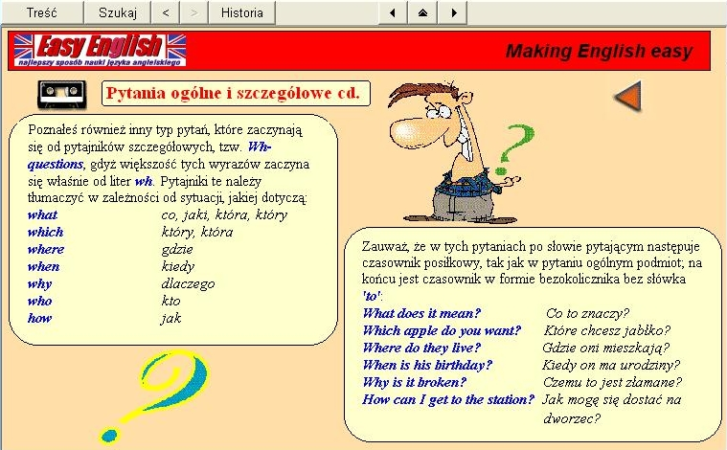

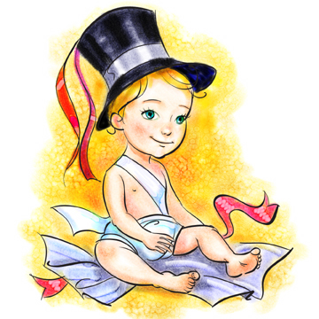**Jokes – jokes about little kids**  
  
[Daddy, daddy, can I have another glass of water, please? But that's the tenth one I've given you tonight! Yes, but the baby's bedroom is still on fire.](http://www.jokes.teksty4u.com/dowcipy,Daddy_daddy_can_I_have_another_glass_of_wate,1127.html)

[Why do we dress baby girls in pink and baby boys in blue? Because they can't dress themselves.](http://www.jokes.teksty4u.com/dowcipy,Why_do_we_dress_baby_girls_in_pink_and_baby_boys_,1156.html)  
  
[Why does a mother carry her baby? The baby can't carry the mother.](http://www.jokes.teksty4u.com/dowcipy,Why_does_a_mother_carry_her_babyThe_baby_ca,1158.html)

another – kolejny tenth – dziesiąty still – wciąż, nadal on fire – w płomieniach carry - nieść

|  |  |
| --- | --- |
| **Time for a quiz** | MCj04124640000[1]  MCj04283330000[1]    Opiekun redakcji gazetki:  Katarzyna Skit |