Small Reporter

February 2016
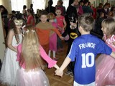
School News

On 16th January there was
a New Year’s Party in our school.
Everyone had a great time.

Remember!

Culture Zone
Valentine’s Rhymes

Roses are Red  Roses are Red  Violets are Blue  Carnations are Sweet  And so are you. | And so are they  That send you this  And when we meet  We'll have a kiss.  Going Steady  Valentine, O, Valentine,  I'll be your love and you'll be mine.  We'll care for each other, rain or fine,  and in 90 years we'll be 99.
Time for a quiz

Name………………………………
Surname……………………………
Class……………………………….

The next issue in March!

